Functional Specification Document

PROJECT: MVP 2 Farming Engagement Hub
EPIC: Farmer Segmentation
Functionality: Farmer Technologies KPI — Processing and Registration
User Story ID: PA-SEG-002
Functional Specification For: (X) Web Application ( ) Mobile Application
Portal: Back Office PA (Web)
Prototype: BAT - Agri 360 — Figma (segmentation flows)

Contents
- 1. Revision History
- 2. Sign-off
- 3. Process Specification
- 4. User Interface & User Experience
- 5. Policy & Regulatory Requirements
- 6. Technical Requirements
- 7. Positive & Negative Testing

1. Revision History
Date | Name | Change | Version
26/05/2026 | Matheus Kist | Initial document draft | 1.0

2. Sign-off
All screens described in this document are operated by the Backoffice PA User within the Back Office PA portal.
Date | Name | Role

3. Process Specification
- What? Register technology adoptions per farmer, crop season, and culture type for Technology KPI scoring.
- Who? Backoffice PA User.
- When? Before simulations where technology adoption affects scores.
- Where? KPI Data — Technologies screen (Web).
- Why? Technology facts are separate from contract KPI rows (multiple technologies per farmer per season).
- How? Grid, manual maintenance, and file import (Phase 1); Agri360-fed data (Phase 2).

3.2 Phased behaviour
Phase | Behaviour
Phase 1 (MVP) | Manual grid maintenance and file import only.
Phase 2 (target Agri360) | Technology adoption data collected by Agri360 (e.g. field notebook, BAT tech package) is written to this KPI store through scheduled routines. Rows are frozen with calculation metadata; the UI is read-only except for authorised overrides.

3.3 Data requirements
One record per Farmer + Crop Season + Culture Type + Technology.
Field | Required | Description
Farmer code | Yes | References Farmer master.
Crop season | Yes | Season identifier.
Culture type code | No | Default FCV.
Technology | Yes | Reference to Technology catalogue.

4. User Interface & User Experience

4.1 SCREEN 01: KPI Data — Technologies (Web)
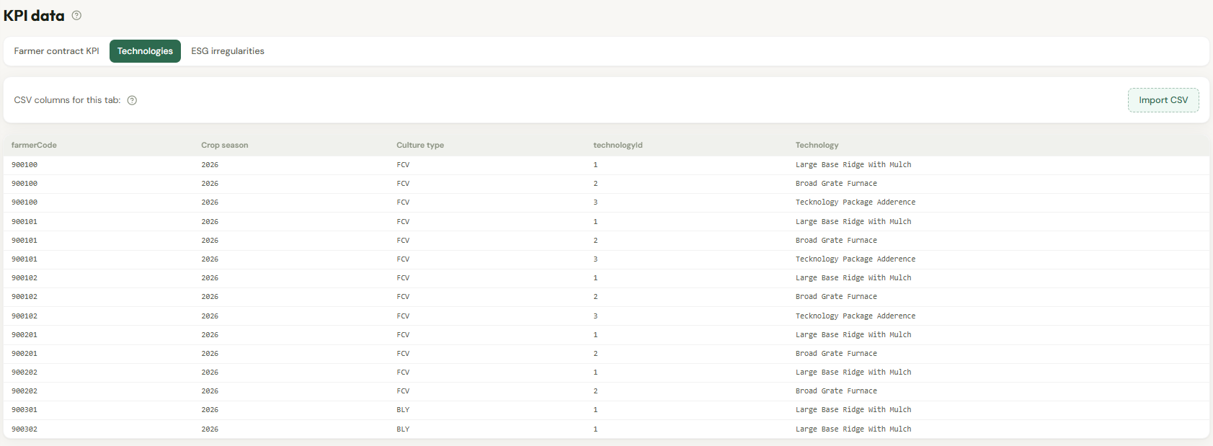
Figure 1 — Wireframe: Technologies KPI screen.

- Grid columns: farmer code, farmer name, crop season, culture type, technology name.
- Toolbar: Import, Add row, Export (optional).
- Add: validate catalogue technology; prevent duplicate natural key.
- Delete: removes adoption for that season.
- Import columns: Farmer code, Crop season, Culture type (optional), Technology identifier.
Help text: Segmentation sums configured technology scores for technologies present in the farmer's latest active season within the simulation Technologies scope (see PA-SEG-005).

5. Policy & Regulatory Requirements
Audit all changes. Segregation of duties vs segmentation approval.

6. Technical Requirements

6.1 Automations
- Phase 1: none (manual and import only).
- Phase 2: scheduled sync from Agri360 technology adoption sources.

7. Positive & Negative Testing
ID | Scenario | Expected result
T-01 | Two technologies same farmer/season | Both contribute to Technology score if configured.
T-02 | Invalid technology reference | Import row error.
T-03 | Delete adoption | Technology no longer scores in simulation.

